CURRICULUM VITAE
YALATTURU SRINIVAS
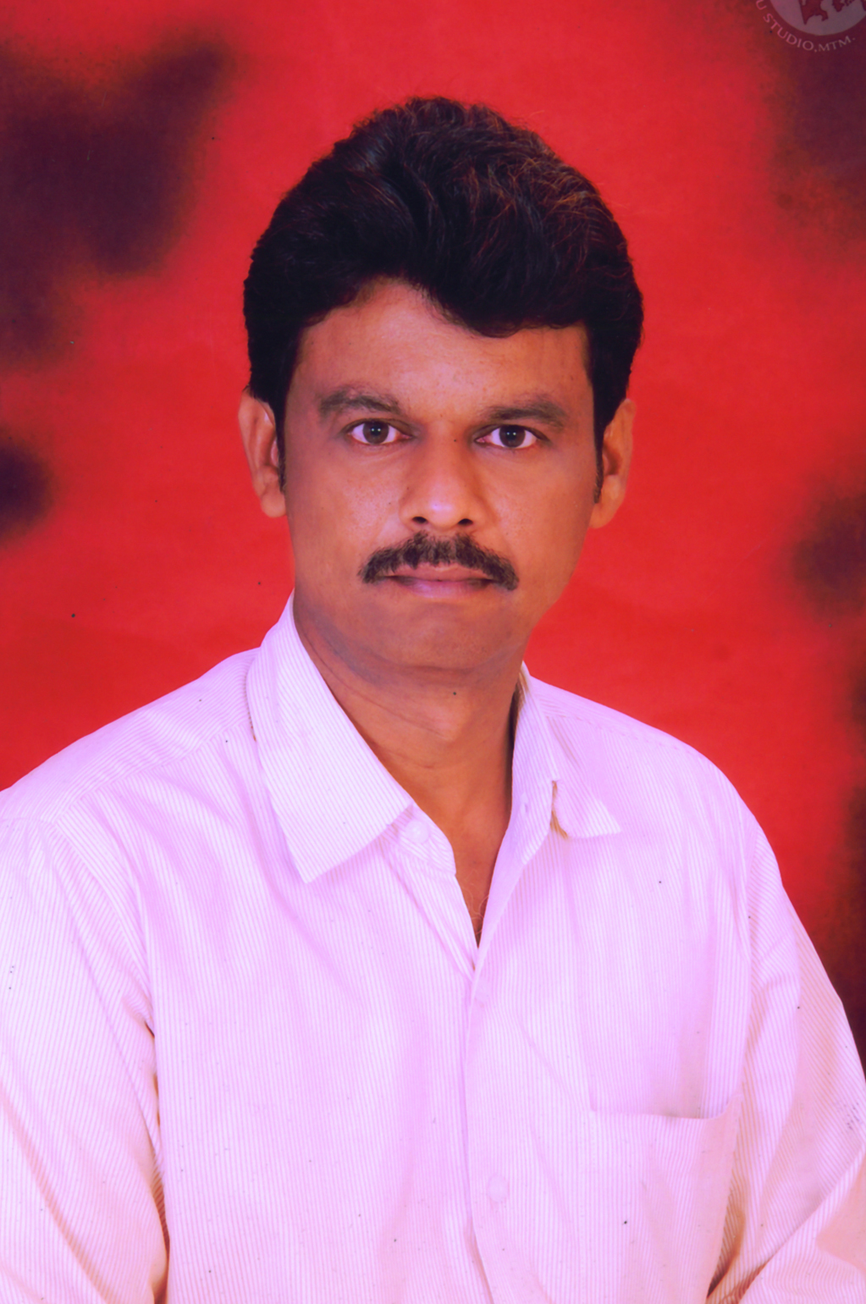
Department: Electronics and Communication Engineering
College: Gudlavalleru Engineering College
Phone No:
Mobile: 9848605577
E-Mail:srinu.yalattur@gmail.com
----------------------------------------------------------------------------------------------------
Address for Communication
D.No: 5-212-1
Javarupet,
Machilipatnam
Krishna Dt.A.P-521001

Academic Qualifications
S. No | Name of the Degree | University | Percentage of Marks/Grade | Specialization | Year of Pass
1 | B.Sc.  Electronics | ANU | 58.4% | Mathematics  Physics  Electronics | 2000
2 | Intermediate | Board Of Intermediate | 55.8% | Mathematics  Physics  Chemistry | 1996
3 | SSC | State Board of Secondary Education | 56% | -- | 1995

Professional Experience
S. No | Designation | Institution Name | Working Period
S. No | Designation | Institution Name | From | To
1 | Hardware Manager | Gudlavalleru Engineering College, Gudlavalleru | 1/03/2012 | Till date
2 | Lab Technician | Gudlavalleru Engineering College, Gudlavalleru | 19/03/2008 | 28/02/2012

Workshops Attended No. : 09

- Two-day workshop on “DEVELOPMENT OF EMBEDDED SYSTEM – A PRACTICAL APPROACH” during 20th-21st August 2014 at Gudlavalleru Engineering College, Gudlavalleru.
- Two-day workshop on “Hands on practice on DTP Tools and Network Trouble shooting” during 28th -29th March 2014 at Gudlavalleru Engineering College, Gudlavalleru.
- Two day workshop on “Design and differentiate Sensors in Embedded Applications” during 14th -15th March 2014 at Gudlavalleru Engineering College, Gudlavalleru.
- one week refresher course on “Electronic Devices and Circuits” during 23rd -28th September 2013 at Gudlavalleru Engineering College, Gudlavalleru.
- Acted as Technical Assistant for Two week ISTE workshop on “Analog Electronics” during 4th -14th June 2013 conducted by IIT, Kharagpur at Gudlavalleru Engineering College, Gudlavalleru.
- Two- day workshop on “PCB design of Electronic Circuits” during 06th -07th August 2012 at Gudlavalleru Engineering College, Gudlavalleru.
- Two -day workshop on “Latest techniques in Network Management and software packages” during 06th -07th July 2012 at Gudlavalleru Engineering College, Gudlavalleru.
- One day workshop on “PLC Applications on 16th June 2012 at Gudlavalleru Engineering College, Gudlavalleru.
- Two day workshop on “Microwave Engineering concepts and lab practice” during 09th -10th June 2012 at Gudlavalleru Engineering College, Gudlavalleru.
Other Responsibilities:

College Level
1.U.P.S Maintenance
2.EPBX Maintenance
3.PUBLIC ADDRESS SYSTEM Maintenance

Department Level

1. Lab Equipment Servicing

Declaration
I hereby declare that all the above-furnished information is correct to the best of my knowledge.

Date:
Place: YALATTURU SRINIVAS

